**TASK1:**  
1.created directory using mkdir command file name is test_dir.  
2.under test test_dir I created dexample.txt. file  
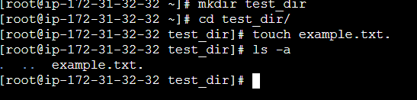

3. After I change file name using miv command

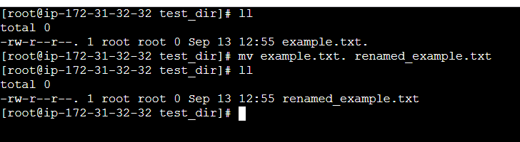

**TASK 2: Viewing File Contents** using cat /etc/passwd.

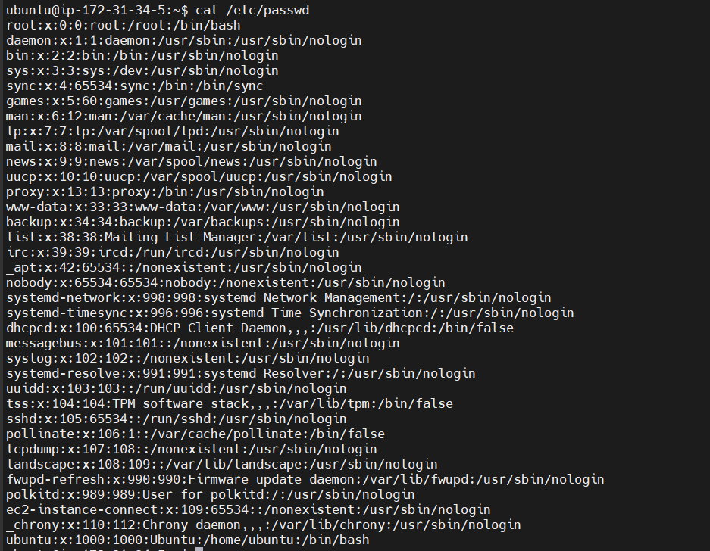

Display first 5 lines using head command  
  
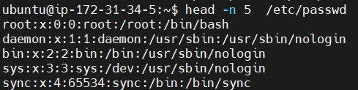

Display last 5 lines using tail command  
  
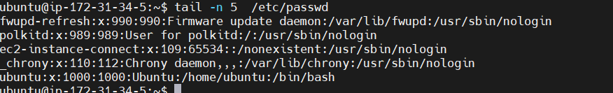  
  
  
**TASK 3: Searching for Patterns**

Display all lines containing the word "root" in /etc/passwd.  
  
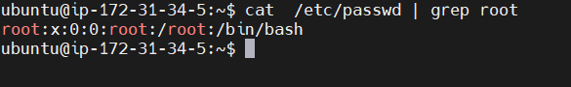  
  
**TASK 4 :  Zipping and Unzipping**  
Compress the test_dir directory into a file named test_dir.zip using zip.

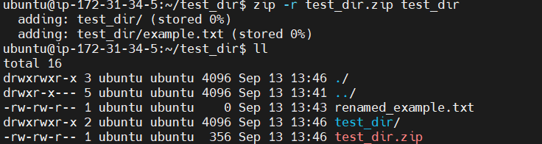

Unzip test_dir.zip into a new directory named unzipped_dir.

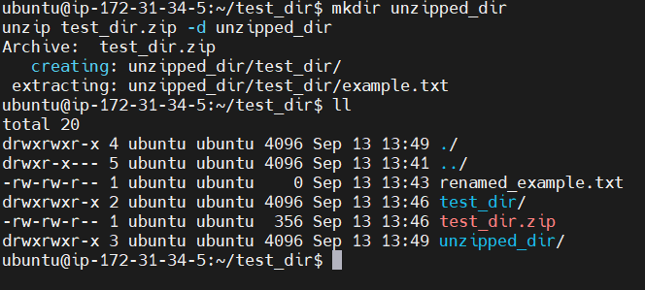

**5. Downloading Files**

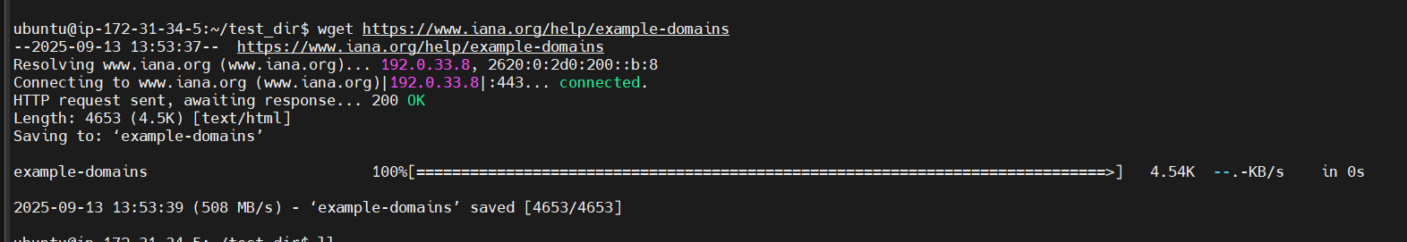

**6. Changing Permissions**

Before changing permission

   
  
After Changing Permission  
  


**7. Working with Environment Variables**

Using export to set a new environment variable called MY_VAR with the value "Hello, Linux!"

